**Annex 4 – BMZ NARRATIVE INTERIM REPORT**

**Christoffel-Blindenmission Deutschland e.V.**

Project Details

|  |  |
| --- | --- |
| CBM Project Number: | 4111_BMZ-MYP |
| BMZ Project Number: | 5226 |
| Project Title: | HEALTH RIGHT: Inclusive Eye and Ear and Hearing Health in Karnali of Nepal |
| City/ Country /Region: | Nepal |

|  |  |
| --- | --- |
| Name of Contractual Partner: | Nepal Netra Jyoti Sangh NNJS |

|  |  |
| --- | --- |
| Duration of Project: | 37 months |
| Project Start Date: | 01.12.2020 |
| Project End Date: | 31.12.2023 |

|  |  |
| --- | --- |
| Report Submitted by: |  |
| Name: | Man Bahadur Kunwar |
| Designation: | Project Manager |
| Email Address: | manbahadurk@nnjs.org.np |

|  |  |
| --- | --- |
| Reporting Period: | 2022/01/01 – 2022/06/30 |
| Date of Submission: | 2022/07/11 |

1. General Information
   1. **Project Short Description / Project Goal**

Karnali is one of the most underdeveloped provinces in Nepal. Basic health service for majority of population is still unavailable and not accessible because of various factors. People have little access to affordable eye and ear care which is fundamental factor influencing the prevalence of blindness and deafness. Surkhet eye hospital, located at province capital in Surkhet is only referral and treatment center for whole province. This project aims to improve the quality of life of poor population of Karnali province affected by visual and hearing impairment by ensuring affordable IEEH service through existing health system, raising awareness on prevention and treatment of eye and ear disease and enhancing professional capacities of service provider.

**Sources of Information (10 lines)**

*Where was the information for the report taken from?*

1. Monthly Progress report
2. Screening data by the community coordinators
3. Workshops/seminar reports/attendances
4. Screening eye and ear camps records
5. Meeting minutes
6. Training reports
7. Surkhet Eye Hospital data
8. Province Hospital data
9. Eye surgical camps data
10. Financial/Financial documents
11. Field visits
12. Status of Implementation of the project

*The impact matrix reflects a current-status in every bi-/annual report*

*All data should be disaggregated (women, men, girls and boys, person with disabilities, no duplications please), if possible.*

|  |
| --- |
| **Overall objective (impact):** The quality of life of the poor population of the province of Karnali affected by visual and hearing impairments is improved. |

**To reach the Overall Objective, the Project aims to reach 4 Results, each equipped with indicators:**

|  |  |  |  |  |  |
| --- | --- | --- | --- | --- | --- |
| **Specific Objective** (Outcome) | **Indicators** | | | | |
| Target | Achievement only in current reporting period in numbers  (quantitative & qualitative)  (January 2022 – June 2022) | Achievement in previous reporting period in numbers  (2021 Annual achievements) | Total accumulated achievement up-to-date till June 2022(cumulative) | Description of achievement so far. Explanation for over-achievement or underachievement of the indicators. |
| Affordable quality IEEH services are part of the health system of the province of Karnali and treatment for poor people is secured. | The population practices measures to prevent eye and ear health (measured by survey). |  |  |  |  |
| 11,920 **poor people** have received treatment for their eye or ear disease.  Please only count the **poor people** which received treatment (in camps, in ECCs and hospital) for free or at a minimum charge | Eye services received=32988  Ear Services received = 1149  Total no. of people received eye or ear services = 34137 | Total eye services received = 18891 | Cumulative achievement = 53028 | Surkhet Eye Hospital started to report/provide the achievements to the project from 2021 and Province Hospital started to report from 2022. 4 new PEECs and 1 upgraded surgical centre are functional. We supported 8 basic health facilities from where the health personnel received 1-month basic otology training and they have also started to deliver ear services. So, we have achieved this cumulative target till the reporting period. |
|  | An agreement for the integration of the established IEEH services into the health system of the province of Karnali has been agreed with the government and ratified in writing. Defined requirements for inclusive barrier-free services are an integral part of the agreement. | As an progressive update, eye health strategy for Karnali province and Federal government is drafted.  The Apex body which is leading the eye health initiatives in Nepal is gradually active and CBM Nepal and NNJS both are active members of this body. | Several level of meetings and discussions some of them are formal and some of them are informal. Mostly supporting on realization of the need of Inclusive Eye health policy. | As an progressive update, eye health strategy for Karnali province and Federal government is drafted.  The Apex body which is leading the eye health initiatives in Nepal is gradually active and CBM Nepal and NNJS both are active members of this body. | Eye Health Strategies have been drafted by the Karnali Provincial Government and Federal Governments. The project will lobby, coordinate and advocate for making the strategies more inclusive and endorsement . Once the government endorses them, only then the agreement of established IEEH services will be materialized. |

|  |  |  |  |  |  |
| --- | --- | --- | --- | --- | --- |
| **Results** (Output) | **Indicators** | | | | |
| Target | Achievement only in current reporting period in numbers  (quantitative & qualitative)  <current reporting period> *please delete accordingly; usually for 6 months)* | Achievement in previous reporting period in numbers  (as stated in previous report) | Total accumulated achievement up-to-date (cumulative) | Description of achievement so far. Explanation for over-achievement or underachievement of the indicators. |
| Result 1.  The population of the 4 target districts of Jumla, Surkhet, Dailekh and Mugu is aware of measures for the prevention and treatment of eye and ear diseases as well of the IEEH services being offered. | By the end of 2023, the population has been made aware of prevention as well as eye and ear treatments and informed about integrated services through 8 street theatres, 60 murals and 8 information panels in public places, 4 school competitions, radio spots and 32 events on special holidays | #Script on street theater has been finalized  # Message and sites have been finalized for the 60 murals and 8 information panels  #Jingles being broadcasted on eye and ear health through 6 FM stations  # The project has planned accomplish school competitions and special day celebrations in 3Q and 4Q. | #Street theatres =0  #Murals = 0  #Information panels =0  # Radio spots = 6 FMs  #School competitions = 2  # Public day celebration = 6 | Street theatres =0  #Murals = 0  #Information panels =0  # Radio spots = 6 FMs  #School competitions = 2  # Public day celebration = 6 | The project is in a good progress of setting the things ready during these previous two quarters of 2022 and most of these targets will be completed within Q3 and Q4 |
| 320 traditional healers, 320 Female Community Health Volunteers, 320 parents, 16 teachers (no budget allocated), 16 community representatives were trained in the prevention and treatment of eye and ear diseases | # Traditional healers = 83  # FCHVs = 152  # Parents = 115 | # Traditional healers = 167  # FCHVs = 177  # Parents = 166 | # Traditional healers = 250  # FCHVs = 329  # Parents = 281 | # Already achieved the targets of whole project period |
| 100 health workers (including 16 teachers), community and district authority representatives were trained on disability, inclusion and inclusive emergency response. | This activity has been planned for Q3 of 2022 | Health workers trained = 26 | Health workers trained = 26 | The project aims at achieving the remaining targets within Q3 of 2022 |
| 16 health care facilities are barrier- free. | #No. of health care facilities completed their accessibility works = 16 | We did the accessibility audit of 16 health care facilities and supported for their accessibility works | No. of health care facilities completed their accessibility works = 16 | Targets have been achieved |
| 4 DPOs with 100 members have strengthened their lobbying skills and are committed to inclusion and accessibility. Participants will come from more than 4 DPOs | This activity has been planned for Q3 0f 2022 | # No. of DPOs members trained on disability and inclusion = 50 | # No. of DPOs members trained on disability and inclusion = 50 | Meet the remaining targets within 2022 |
| Result 2.  In the target districts of Jumla, Mugu, Surkhet and Dailekh professional capacities and infrastructure for affordable IEEC services are permanently guaranteed. | 12 basic health stations and 4 primary health centres are equipped with ophthalmic and ear medical services in the target communities for basic care of the population. | # No. equipped basic health stations = 8  # No. of equipped primary health centres = 4 | # No. equipped basic health stations = 0 (NNJS only procured equipment in end of 2021)  # No. of equipped primary health centres = 0 (NNJS only procured equipment in end of 2021) | # No. equipped basic health stations = 8  # No. of equipped primary health centres = 4 | Remaining 4 basic health stations will be equipped within Q3 of 2022 |
| 8 community coordinators and 100 community nurses working in the 16 health stations are trained in ophthalmology. They are integrated into a referral system with 2 eye clinics and 1 ENT department at the tertiary provincial hospital. | # No. of community nurses trained = 73 | # No. of community coordinators trained =8  # No. of community nurses trained = 42 | # No. of community coordinators trained =8  # No. of community nurses trained = 115 | Already achieved the total targets of whole project period, the trained nurses and community coordinators will be providing services in regular basis. |
| 2 eye clinics and 1 ENT department of the tertiary provincial hospital have received necessary medical equipment for further treatment and work together with health stations. 22 health workers were trained in audiology/orthology and 1 technician in maintenance of medical equipment. | # Eye clinics equipped = 2  # ENT Department supported = 1  # Health workers trained in audiology = 6  # Technician trained = 0 | # Eye clinics equipped =0 (NNJS only procured equipment in end of 2021)  # ENT Department supported = 0 (NNJS only procured equipment in end of 2021)  # Health workers trained in audiology = 10  # Technician trained = 0 | # Eye clinics equipped = 2  # ENT Department supported = 1  # Health workers trained in audiology = 16  # Technician trained = 0 | # Remaining 6 health workers will complete the audiology training within Q3 of 2022  # 1 technician from Surkhet Eye Hospital will join the maintenance training from August 2022 |
| 126,000 (planned number is way too low) people participated in 32 mass screenings in schools and communities. | # No. of people participated in mass screenings = 36012 | # No. of people participated in mass screenings = 20829 | # Total No. of people participated in mass screenings up to date= 56841 | The project target for mass screening is on track. |
| 3,200 people were screened in 18 community screening programmes for early detection of hypertension, retinopathy and glaucoma. | # No. of people screened for early detection = 0 (planned for Q3 and Q4) | # No. of people screened for early detection = 402 | # No. of people screened for early detection = 402 | # We have plan to screen 1800 people this year and will be achieved within Q3 and Q4 of 2022 |
| 8,400 poor people from the communities have received cataract surgery and 320 people have received ear treatment. | # No. of people received cataract surgery = 2027  # No. of people received ear surgeries = 41 | # No. of people received cataract surgery = 2887 (351 under subsidy support)  # No. of people received ear surgeries = 17 | # No. of people received cataract surgery = 4914  # No. of people received ear surgeries = 58 | # Surgical achievement from Surkhet eye hospital (SEH) has been updated from 2021. Till the reporting period, a total of 4914 cataract surgeries were done by SEH  Province Hospital ear surgeries are started to record from 2022, after equipment support. During the reporting period a total of 41 ear surgeries were done, out of them 7 ear surgeries have been performed under Project subsidy |
| Result 3. Integration of accessible IEEH services in the state health system is ensured. | In 4 lobbying meetings with representatives of the district and provincial authorities, transfer of established IEEH services to the provincial medical health system was approved and signed. | This activity has been planned for Q3 and Q4 of 2022 | Lobbying meeting with Ministry of Social Development (MoSD) = 1 | Total Lobbying meeting = 1 | A provincial level eye health strategy has been drafted by the ownership of MoSD of Karnali Province. The project will organize the lobbying meetings with them in Q3 and Q4. This will support/pressurize to address the transfer of IEEH services under the provincial health system., similarly, lobby, coordination at national level will be carried out for endorsement of national eye health strategy. |
| In four workshops, government representatives were given expert advice on the development and implementation of the strategy for IEEH services into government health programmes, and an MoU with an implementation plan was adopted and signed. | # We have planned to conduct policy discussion and dialogue workshops at Provincial and National level in Q3 and Q4 of 2022 | #This activity could not be accomplished in 2021 |  | # Two drafts on eye health strategies have been formulated at the province and national levels. We will organize policy review, coordination lobby meetings for the expert advice in Q3 and Q4 among government authorities and concerned stakeholders. After government endorsement of policy, the MoU with an implementation will happen |
| In 4 lobbying meetings and 4 workshops, DPO representatives have ensured that the agreements and implementation plans take into account the inclusion of people with disabilities. | NNJS will ensure the participation and engagement of DPOs in those lobby meetings and workshops planned for Q3 and Q4 | # Lobbying meetings conducted =1 | # Lobbying meetings conducted = 1 | # Lobbying meetings will be conducted in Q3 and Q4  #Policy reviews and formation workshops planned in Q3 and Q4 |

**2.1 Further Explanations for Changes and adaptions in initial project plan**

*In case there were changes in partner NGOs, Staff, framework, Project results, indicators and project area or target group, this needs to be explained here.*

***a. Status of implementation of activities, in comparison to proposal***

*This is the main part of the report, where the focus is on the progress of the project implementation for the reporting year. Here we give detailed description of all implemented activities in the reporting period with photos, breakdown of target group reached per activities (women, men, girls and boys, person with disabilities, no duplications please). Hereby, we follow the structure of the proposal, describing each activity under each result.*

*If one of the results or activities have not been achieved/implemented although they were planned to be implemented in the reporting period, please describe the reason for delays, variations, challenges, obstacles and how you have or will scope them.*

**Result 1: The population of the 4 target districts of Jumla, Surkhet, Dailekh and Mugu is aware of measures for the prevention and treatment of eye and ear diseases and of the range of IEEH services.**

**1.1 Information on prevention and treatment of eye and ear diseases as well as disability and inclusion**

|  |
| --- |
| **1.1.1 Radio spots to inform people about eye and ear health** |
| Radio message on eye health awareness has been being broadcasted through 6 FM/Radio stations covering the project districts since 2021. We have also developed few other awareness raising messages on eye and ear health as well as for informing IEEH services for effective referral networks. We will finalize the contents after discussion meeting with our technical partners Surkhet Eye Hospital and ENT Department of Province Hospital. We have planned to broadcast additional messages within Q3 of 2022. Also, we relay radio spots and jingles during the eye and ear surgical and screenings camps so that the communities be informed about the time, place and services to be utilized. |

|  |
| --- |
| **1.1.2 Street theatre to raise awareness of eye and ear health** |
| Two scripts on eye and ear health have been drafted by a hired consultant from a local cultural agency and we are reviewing them in consultation with DPOs representatives, technical partners and CBM focal person.  We have planned to show the street drama since the first week of August 2022 and accomplish all 8 events within 2022. We will coordinate with the provincial and local DPOs and engage them before and during the public display of the street drama. The main purpose is to educate, inform and empower the local communities to inculcate positive promotive and preventive measures on eye and ear health, to inform about the IEEH services and to enhance their service seeking behaviors for their eye and ear problems |

|  |
| --- |
| **1.1.3 Design and production of information material** |
| We have designed and printed 15 stickers, 50 flexes and 2500 brochures on eye health awareness, 50 flexes and 2000 posters on ear health awareness. We have been displaying them during regular eye and ear screening campaigns, surgical eye and ear camps, schools and other public places like health facilities. We also distribute pamphlets to aware and inform the communities before conducting surgical eye and ear camps so that they would be informed to utilize the services during the campaigns. We have also designed and printed pamphlets on eye and ear health in accessible Braille Format so that they will be accessible to the people with incurable Blindness and visual impairment. They will be distributed in the schools where inclusive education is provisioned, during the DID trainings and seminars, surgical eye and ear campaigns and the DPOs working for the welfare of people affected with incurable blindness and visual impairment. |

|  |
| --- |
| **1.1.4 Wall paintings in central places in communities** |
| We have developed contents for awareness in eye and ear health to be displayed through 60 murals (wall paintings in the project sites). We are reviewing the contents in consultation with technical partners, DPOs representatives and CBM focal person. We have planned to complete this activity within Q3 of 2022. There will be altogether 60 wall paintings on eye and ear health awareness: 8 in Gurvakot(Surkhet), 8 in Barahatal(Surkhet), 8 in Narayan(Dailekh), 8 in Dullu(Dailekh), 8 in Sinja(Jumla), 8 in Chandannath(Jumla), 8 in Rarachayanath(Mugu) and 4 in Soru(Mugu).  We have already identified the specific sites for the wall paintings like schools, health facilities and public places. Our field coordinators officially coordinated with local government authorities, schools and health coordinators and finalized venues and sites for the wall paintings jointly.  The contents on the wall paintings will aware the communities in eye and ear health, inform them regarding availability and provision of IEEH services. It is expected that this will enhance their health seejing behaviors for their eye and ear problems. |

|  |
| --- |
| **1.1.5 Video spot production** |
| We have coordinated with Surkhet Eye Hospital and Province Hospital for their technical support for developing video spots on eye and ear health respectively. It is more effective to produce the video spots on local dialects so that the local communities can easily comprehend and adopt.  We are also trying to modify the already produced video spots by NNJS previous eye health programs. We will start this activity within Q3 of 2022. |

|  |
| --- |
| **1.1.6 Production of information boards for schools and public places** |
| We have developed contents for awareness in eye and ear health to be displayed through 32 hoarding boards in the project sites. We are reviewing the contents in consultation with technical partners, DPOs representatives and CBM focal person. We have planned to complete this activity within Q3 of 2022.  We have already identified the specific sites like schools, health facilities and public places. Our field coordinators officially coordinated with local government authorities, schools and health coordinators have finalized place and location for the hoarding boards.  Awareness information will be disseminated through hoarding boards in schools and public places within Q3 of 2022: 8 in Surkhet, 8 in Dailekh, 8 in Jumla and 8 in Mugu covering our project sites. |

|  |
| --- |
| **1.1.7 Competition on health practices** |
| We could not organize competition events on eye and ear health practices in Q1 and Q2 of 2022 due to annual examinations, winter vacations , local elections and new admissions programs in the schools in project sites. We will conduct and complete the events befor December 2022.  The main aim of this activity is to sensitize the students on eye and ear health, to aware them regarding their eye and ear health problems, to promote their healthy habits. |

**1.2 Mobilisation and capacity development in the communities**

|  |
| --- |
| **1.2.1 Training community coordinators (Eye and Ear Health Worker)** |
| 8 Community Coordinators (2 Men, 6 Women) have been trained on eye and ear health. Out of them, 2 (1 Men, 1 Women) are persons with physical disability. The main purpose is to enhance their knowledge and skills on eye and ear health so that they are able identify and refer the eye and ear problems, aware the communities on eye and ear health and inform them regarding the availability and provision of IEEH services. |

|  |
| --- |
| **1.2.2 Training of Female Community Health Volunteers (FCHV)** |
| As part of Community Mobilization on eye and ear health A total of 152 FCVHs were trained on eye and ear health in one day orientation programs. They were 20 in Soru Rural Municipality (Mugu), 45 in Sinja Rural Municipality (Jumla), 40 in Chandannath Municiplaity (Jumla) and 47 in Dullu Municipality (Dailekh).  All the training events were held with great excitement and active participation of the FCHVs. The main purpose of orienting them is to aware them on preventive measures on eye and ear health, inform them regarding availability and provision of IEEH services so that they can effectively play a vital role for referral network.  **Few of the trainees expressed:** For a long time, we were not made aware about eye and ear by any organization even the government, from this orientation we are very happy and excited, now we understood the value of vision and hearing, we will refer any cases we find in the communities.‘ |

|  |
| --- |
| **1.2.3 Training of traditional healers** |
| Traditional healers in Nepal are those persons who do not have any formal medical training, but are considered (by the local community) as being competent to provide health care using animal, plant and mineral substances and certain other techniques based on social, cultural and religious background. The local communities have deep faith on them and many times, are subject to harmful health practices due to deep rooted cultural and harmful religious beliefs.  A total of 83 traditional healers were oriented for awareness on eye, ear and disability. They were 33 in Dullu Municipality (Dailekh) and 50 in Chandannath Municipality (Jumla). The main objective of this training is to avoid any malpractices by the traditional healers against eye and ear problems among the community people to make them aware about availability and provision of IEEH services.  **Few of them expressed at the end of orietation:** *“Now after your orientation our eyes are open, we are clear now, we will never try to treat with harmful materials and methods, we will immediately refer to the health facility when anyone comes to us with health problems including eye and ear.”* |

|  |
| --- |
| **1.2.4 Training for parents on eye and ear health** |
| A total of 115 parents were made aware of eye and ear health in one day orientation programs. They were 63 from Dullu (Dailekh) and 52 from Sinja (Jumla).The main aim of the training is to sensitize them on eye and ear health to timely seek medical services for their children.  ***Some of the parents expressed:”*** *We now understand the importance of good vision and hearing, we will encourage our children to wear glasses for their vision impairment, healthy diet and outdoor activities for good vision, consult health personnel rightly when our children get any eye and ear problem, the orientation has made us know many things about eye and ear health.”* |

|  |
| --- |
| * + 1. **Capacity development of community nurses on eye and ear diseases and rehabilitation** |
| Community nurses are the important front line health personnel in Nepal who have been playing significant roles for preventing child and maternal deaths. They involve in community health activities such as antenatal care, child birth, post natal care, routine immunization, family planning, nutritional promotion. Enhancing their knowledge and skills on eye and ear health can play an important role for early detection, referral and treatment of eye and ear problems thereby reducing vision and hearing impairments during the critical development periods of human life.  A total of 73 community nurses were trained on eye, ear and rehabilitation in 3 days’ advanced training programs. They were 15 from Dullu (Dailekh), 11 from Narayan (Dailekh), 15 from Soru (Mugu) and 17 from Chhayanath (Mugu). |

|  |
| --- |
| **1.2.6 Training of health personnel on emergency response measures** |
| The main purpose of this training is to enhance knowledge and awareness of the state health personnel on special vulnerability of the emergency situations of the people with disabilities and inclusive community emergency plans. This activity will be accomplished within Q3 and Q4 of 2022 in Dailekh, Mugu and Jumla districts by conducting 3 workshops with 75 perspective participants. |

|  |
| --- |
| **1.2.7 Training in Disability and Inclusion**  **Further training of health personnel on emergency response measures** |
| Blindness, vision impairment, deafness and hearing impairment are the most common disabilities in the project sites. Reduction of the causes of these impairments with disability inclusion is the main purpose of the project. The main purpose of this training is to enhance the knowledge and skills of the DPOs members lobbying and their committment to disability and inclusion.  Two training workshops for empowering 50 DPOs members will take place in Jumla and Mugu in Q3 of 2022. |

**Result 2: Result 2: In the target districts of Jumla, Mugu, Surkhet and Dailekh the professional capacities and infrastructure for affordable IEEH services are permanently guaranteed.**

**2.1 Building inclusive eye and ear health services**

|  |
| --- |
| **2.1.1 Regular screening in communities and schools** |
| Regular screening in communities and schools is the single major activity of our 8 community coordinators. They work in close coordination with the local government authorities, school teachers, FCHVs and government health personnel for conducting community and school screening campaigns. In the screening campaigns, they mainly aware the community people and students on promotive and preventive measures on eye health, screen for eye and ear problems and make referrals to different health facilities and also inform them about the availability and provision of IEEH services.  During the reporting periods, a total of 36012 screenings (11352 girls, 11718 boys, 6138 men, 6804 women) were done for detection of eye and ear problems at schools and communities by 8 community coordinators. A total of 819 people were referred for their eye problems and 376 people were referred for their ear problems. There were 220 people with disabilities among screened population. |

|  |
| --- |
| **2.1.2 Early detection in mass screening** |
| This activity could not be accomplished in the reporting period since we were engaged in conducting cataract screening and surgical camps in remote places with technical support from Surkhet Eye Hospital. Early detection in mass screening of glaucoma, diabetes retinopathy and hypertensive retinopathy has been planned during Q3 and Q4 of 2022. The required targets of screening at risk groups in the communities will be met within 2022.  The main purpose of this activity is to timely detect the cases of glaucoma, hypertension and diabetics, among at risk groups of the population, as the emerging causes of blindness and visual impairment. The technical team led by an ophthalmologist will carry out the community mass screening campaign along with awareness raising. |

|  |
| --- |
| **2.1.3 Special Public celebration days** |
| This activity is conducted by organizing events on special days such as World Sight Day, World Diabetics Day, International Day of Persons with Disabilities (IDPD) etc. The main purpose is to draw attention government authorities, DPOs and communities on prevention of eye and ear diseases as well as disability and inclusion.  In 2022, World Sight Day on 13 October and International Day of Persons with disabilities on 3 December have been planned to be observed. A total of 16 events will be organized at the local level in 8 project sites and 2 events will be organized at the provincial level. |

**2.2 Building integrated eye and ear health services**

|  |
| --- |
| **2.2.1 Baseline study on ear and hearing care** |
| Karnali is the most underprivileged province of Nepal. Status of persons with deafness and hearing difficulties is yet to be identified. Reliable, standardized, population-based data on hearing impairment in Karnali province is of urgent need for evidence based planning of ear care services. An EoI has been published seeking for proposals from prospective research firms/consultancies/organizations for their interests in carrying out the ear and hearing survey in Karnali by following the WHO guidelines. |

|  |
| --- |
| **2.2.2 Equipment of the state basic health stations** |
| We have supported equipment to 8 basic heath stations and planning to support additional 4 health station in 2022. Procurement is under process, and NNJS has planned this activity to complete within Q3. To maximize the utilization of provided equipment, project have been providing equipment to those health facilities from where health personnel have participated on one-month basic otology training. Doing this project has ensured the utilization of provided equipment and those who have received training have equipment to practice their learned knowledge and deliver services. During the reporting period total of 144 (men-31, women-34, boys-36, girls-43) people have received the basic ear service. |

|  |
| --- |
| **2.2.3 Establishment of an integrated eye and ear health service in Primary Health Centres** |
| Under the project support, the 4 new primary eye and ear care centers (PEECs) are established and functional to provide primary eye services in rural community. They are established at Patarasi(Jumla), Kanakasundari (Jumla), Dullu (Dailekh) and Simta(Surkhet) municipalites. The local governments have taken the ownership to manage HR and operational costs. Regular monitoring and supervision will be done by the management committee formed for running the PEECs. NNJS will support for technical capacity enhancement of the staff.  A total of 395 community people (114 Men, 183 Women, 60 boys, 38 girls) have received eye care services in the reporting period from newly established 4 PEECs. |

|  |
| --- |
| * + 1. **Upgrade of one primary health center to an eye clinic**     2. **2.1.2 Early detection in mass screening Building up an eye clinic** |
| Gurvakot eye care center has been upgraded to surgical center with equipment support from this project. Locally formed eye care center management committe manage this surgical center. Local governemet also allocate fund for this eye care center anually about NPR 700000 to 1000000. Additionnaly, this center receive annual support from NNJS for HR, admin and other logistic. Local goverment and NNJS are agreed to upgrade this surgical center further as secondary eye hospital in future.  The upgraded surgical centre at Gurvakot has started to provide periodic surgical services and also providing daily out patient services. Durign the semiannual reporting period of 2022, a total of 1669 community people (690 women, 600 men, 200 girls, 179 boys) have received eye care services. Out of them 77 cataract surgeries of 43 women and 34 men have been conducted with periodically visiting opthalmologist from Surkhet Eye Hospital. NNJS is planning to recruit an ophthalmologist at the centre for regular surgical and other clinical services in near future. |

|  |
| --- |
| * + 1. **Establishment of a low vision department at Surkhet Eye Hospital** |
| The following equipments have been procured under the financial support from BMZ and handed over to Surkhet Eye Hospital:   |  |  |  | | --- | --- | --- | | **S.N.** | **Devices For Low Vision Clinic at SEH** | **No** | | **1** | Streak retinoscope | 1 | | **2** | Direct ophthalmoscope | 1 | | **3** | Trial lens set (full aperture) | 1 | | **4** | Universal trial frames | 1 | | **5** | Pediatric trial frames (2 pairs of different sizes) | 2 | | **6** | Long handle occluder with pinholes | 2 | | **7** | Pen torch | 1 | | **8** | Distant LogMAR test charts | 3 | | **9** | Near vision tests | 4 | | **10** | Symbol pediatric tests for matching and pointing (with and without crowding) | 2 | | **11** | PV-16 Color Vision Test (double set) | 2 | | **12** | Spectacle magnifiers (half eyes) | 12 | | **13** | Foldable and hand-held magnifiers with and without built-in light source | 12 | | **14** | Stand magnifiers | 12 | | **15** | Dome and bar magnifiers | 8 | | **16** | Hand-held monocular telescopes | 8 | | **17** | Filters | 10 | | **18** | Color TV Set | 1 | | **19** | Black and white hand-held CCTV magnifier | 1 | | **20** | Full color hand-held CCTV magnifier | 1 |   Surkhet Eye Hospital is planning to hire a low vision expert for providing the regular low vision services. Full fledge service planned to start by this year. |

|  |
| --- |
| * + 1. **Improvement of eye health services at the Surkhet Eye Hospital** |
| The project supported the following equipment’s under the project funded by BMZ grant for upgradation of the ophthalmological services:   |  |  | | --- | --- | | Name of Equipments | Quantity | |  | | Humphry | 1 |  | | Slit Lamp | 1 |  | | Loose prism | 1 |  | | Kitmus Set | 1 |  | | Computerized vision drum with magic chart | 1 |  | | Pachymetry | 1 |  | | Edging machine | 1 |  |   We have tracked the service delivery performance of Surkhet eye hospital from June 2021, inception of this project. From June to December 2021 SEH provided service to 18891 people (men-7233, women-10500, boys-623 and girls-535). Similarly, SEH has provided service to 28395 people (11432 Men, 15293 Women, 932 Boys, 738 girls) during reporting period (Jan-June 2022). Overall, SEH has able to reach more people during the first half of 2022 as compared to second half of 2021. This could be BMZ support on expanding and strengthening their services through equipment support, human resources support and expanding services to remote places throughout-reach camps and subsidy to poor people. |
|  |

|  |
| --- |
| * + 1. **Strengthening the ENT department at Karnali Provincial Hospital in Surkhet** |
| The following Ear equipments have been handed over to Karnali Province Hospital under the financial support from BMZ for strengthening the ENT department:   |  |  |  | | --- | --- | --- | | **S.N.** | **Name** | **No.** | | **1** | Myringoplasty set | **2** | | **2** | MRM set | **2** | | **3** | Tympanometer | **2** | | **4** | Pure Tone Audiogram (PTA) | **2** | | **5** | General ENT OPD working MRM Dril | **1** | | **6** | PTA Tympanometry unit with Audiogram | **2** | | **7** | Head Lights | **4** | | **8** | Suction machine | **3** | | **9** | Tunning Forks (256,512,1024 HZ) | **6** | | **10** | Ear OPD Instruments | **1** | | **11** | Ottoscope | **5** | | **12** | Portable Microscope | **1** |   In the reporting period, a total of 1005 people (276 women, 296 men, 196 girls, 224 boys) have received the ear care services at province hospital including 13 Persons with disability (6 Men, 2 Women, 1 Boy, 4 Girls). Provincial hospitla has done 41 ear surgeries during reportign period, 7 out of them from the project with BMZ funded subsidy support. |

|  |
| --- |
| **2.2.8 Improvement of accessibility at the primary health center** |
| The following health facilities have been audited and supported for the accesibility work:   |  |  |  | | --- | --- | --- | | S.N. | Name | Address | |  | Kunathari Health Post | Barahatal, Surkhet | |  | Lekhgaun Health Post | Barahatal, Surkhet | |  | Sahare Health Post | Gurvakot, Surkhet | |  | Dahachour Health Post | Gurvakot, Surkhet | |  | Primary Eye Care Center | Narayan Municiplaity, Dailekh | |  | Belaspur Health Post | Narayan Municiplaity, Dailekh | |  | Tribeni Health Post | Narayan Municiplaity, Dailekh | |  | Community Eye Care Center | Dullu Municipality, Dailekh | |  | Gamaudi Health Post | Dullu Municipality, Dailekh | |  | Paduka Health Post | Dullu Municipality, Dailekh | |  | Dhapa Health Post | Sinja Rural Municiplaity, Jumla | |  | Narakot Health Post | Sinja Rural Municiplaity, Jumla | |  | Sanigaun Health Post | Sinja Rural Municiplaity, Jumla | |  | Primary Eye Center | Chandannath Municipality, Jumla | |  | Talium Health Post | Chandannath Municipality, Jumla | |  | Mahat Health Post | Chandannath Municipality, Jumla |   Accessibility improvement of all 16 health facilities have been completed. Accessibility audit has helped to sensitize local government, respective institute personnel and community people. As a result, local government and other stakeholders provided financial support to improve the accessibility of primary health centers. Similarly, we have observed community participation to make health facilities accessible through labour contribution. This activity has raised the awareness and importance of accessible physical structure/buildings. Local government and health staff have highly appreciated our support and initiation. |

|  |
| --- |
| * + 1. **Cataract surgery at Surkhet Eye Hospital** |
| In the reporting period, a total of 1258 cataract surgeries of 520 Men, 735 Women and 3 Boys were performed at Surkhet Eye Hospital. Out of them, 153 cataract surgeries of 71 Men and 82 Women were done under the subsidy by BMZ funded Project. National Insurance scheme covered for 428 cataract surgeries and remaining 677 were either supported by other entities or out of pocket expenditures.  Similarly, in 2021, SEH has performed 2664 cataract surgeries from June to December 2021. Among them 128 (66 men and 62 women) surgery were performed with support from BMZ subsidy and 477 were from health insurance.  Altogether, 281 cataract surgeries have performed at Surkhet eye hospital under BMZ subsidy till June 2022.  Due to geographical remoteness, lack of transportation, and peoples’ excessive dependence in outreach surgical camps, many people don’t visit base hospital (SEH) for eye surgeries. Among them who visit SEH for surgeries, if they are financially able to cover the cost of surgeries, they cover themselves, those clients who have health insurance, their surgeries are covered by health insurance. If client from project district is poor and unable to cover surgery cost then, surgeries are done under project subsidy scheme. |

|  |
| --- |
| * + 1. **Implementation of cataract surgery campaigns in remote regions** |
| A total of 769 cataract surgeries of 391 Men and 378 Women were performed at the 7 surgical camps held in Mugu, Jumla, Dailekh and Surkhet districts in 2022 from January to June 2022.  In 2021, A total of 223 cataract surgeries of 114 Men and 109 Women were performed. Altogether, 992 cataract surgeries were performed under BMZ project support till June 2022.  Similarly, a total of 2529 community people (1005 Men and 1524 Women) received eye care services during the outreach surgical eye camps in the reporting period. |

|  |
| --- |
| * + 1. **Ear surgery campaigns** |
| In the reporting period, a total of 41 ear surgeries of 10 Men, 13 Women, 14 Boys and 4 Girls were conducted at the ENT Department of Province Hospital.Out of them, 7 ear surgeries of 5 men, 1 woman, 1 boy) were conducted under the BMZ subsidy support. Similarly, 17 surgeires were performed in 2021. Altogether, 24 surgeies have done till June 2022  NNJS is plannign to do ear campaings in remote place to identify and refere ear client for surgery, which is expected to increase number of people receivieng eye surgery |

* 1. **Capacity development in the state health sector**

|  |
| --- |
| **2.4.1 Training on maintenance of medical equipment**  **Workshop presentation including school clubs** |
| 1 technician from Surkhet Eye Hospital will join one month maintenance training in a renowned eye institute at Madurai, India. The project will support all the expenses including training fees, travel, accommodation and food. After this training, Surkhet eye hospital will have their own skilled maintenance human resources. |

|  |
| --- |
| * + 1. **Audiology training of state health personnel** |
| In the reporting period, 6 health personnel (2 Women, 4 Men) from project sites in Jumla, Dailekh and Surkhet) have been trained for basic otology at Karnali Province Hospital under the financial support by BMZ Project. We provide same traigin to 10 health personnel in 2021. Till june 2022, alltogeher 16 health personnel are trained in basic otology traing. We have explored the trainign institue and communicated with local/provincial governemnt to select participant for 3 month audiology trainign for 2 people, which is expected to start from september 2022.  The main purpose of training is to impart the health personnel knowledge and skills on audiology so that primary ear care service is ensured at the basic level. This will contribute to the prevention of deafness and hearing impairment in the province. After the training, they will provide regular primary ear services from their respective health facilities and the project will support basic ear equipments so that the service will start on time. They will report to the project on monthly basis regarding the achievement of their service provision. |

**Result 3: The integration of integrated ophthalmic and otologic services in the public health system is ensured**

|  |
| --- |
| **3.1.1 Lobbying meeting with representatives of local, district and regional authorities** |
| The main purpose of lobbying with local, district and regional authorities is to advocate for the integration of eye and ear care services into the mainstream health system and ensure the inclusion of people with disabilities in plans, policies and programs. The provincial, district and local, government authorities, DPOs members, representatives from Surkhet Eye Hospital and Province Hospital are to participate in the 2 lobby meetings. We have planned this activity in Q3 and Q4 of 2022. |

|  |
| --- |
| **3.1.2 Eye and ear health committee at district level** |
| A total of 8 Eye and ear committee have been formed within the project framework to review, feedback and facilitate the project activities at the local levels. Participation of DPOs members is mandatory and our field staff coordinate for the meetings and in the reporting period, a total of 13 meetings have been held in the project sites among the local government authorities, DPOs members during reporting period. During the meetings, they have discussions regarding the implementation of project activities, challenges faced and ways forward.  The committee have been very useful for implementing the project activities mainly regular eye and ear screenings, conducting surgical eye and ear campaigns, and many other activities regarding system and capacity enhancement. |

|  |
| --- |
| **3.1.3 Revision of the National Health Strategy** |
| As provisioned in national health policies, government of Nepal aims to integrate the eye and ear health into the National Health System. For this broad policy dialogue consultation meetings are to be held for the wide discussion over the drafted policies and strategies.  Two drafts on eye health strategies have been formulated at the province and national levels. We will organize policy review, coordination lobby meetings for the expert advice in Q3 and Q4 among government authorities and concerned stakeholders. Until and unless the government endorses the policy only the MoU implementation will happen. NNJS and CBM is working as member closely with APEX body which is advisory body for eye policy in Nepal. |

|  |
| --- |
| **3.1.4 Disability Inclusive Development (DID) Training** |
| The aim of this activity is to ensure that state actors take inclusion into account when planning their programs. For this, representatives of health, social and educational authorities along with DPOs representatives are called for a 3 Day seminar to be trained on the concept of Disability Inclusion and Development.  Based on this provision, 3 Day DID seminar will be held at Surkhet within Q4 of 2022. |

**2.2 Cooperation with other actors in the reporting period (beyond project partners)**

Interactive meetings and discussions were held with local authorities in 5 municipalities in the project districts regarding sustainability issues of 4 new Integrated primary eye and ear centers and 1 surgical eye center.

We officially coordinated with the local government entities since the beginning of the project implementation. Regarding the regular screening activities by our field coordinators, local leaders, ward chairman, FCHVs and government health personnel are supporting. We supported 8 government health facilities with basic eye and ear equipments, trained 6 health personnel on basic otology in coordination and collaboration with local authorities. We coordinate with DPOs, schools and communities for the implementation of different project activities in our area.

**2.3 Activities planned in following period (Q30):**

|  |  |
| --- | --- |
| R01 | The population of the 4 target districts of Jumla, Surkhet, Dailekh and Mugu is informed about prevention, treatment options and IEEH services. |
| A01.01 | Radio spots to inform people about eye and ear health |
| A01.02 | Street theatre to raise awareness of eye and ear health |
| A01.04 | Wall paintings in central places in communities |
| A01.05 | Video spot production |
| A01.06 | Production of information boards for schools and public places |
| A01.07 | Competition on health practices |
| A01.13 | Training of health personnel on emergency response measures |
| A01.14 | Training in Disability and Inclusion |
| R02 | **In the target districts of Jumla, Mugu, Surkhet and Dailekh the professional capacities and infrastructure for affordable IEEH services are permanently guaranteed.** |
| A02.01 | Regular screening in communities and schools |
| A02.02 | Early detection in mass screening |
| A02.03 | Special Public Celebration Day |
| A02.04 | Baseline study on ear and hearing care |
| A02.05 | Equipment supports to Basic Health Stations |
| A02.12 | Cataract surgery at Surkhet Eye Hospital |
| A02.13 | Implementation of cataract surgery campaigns in remote regions |
| A02.14 | Ear surgery campaigns |
| A02.15 | Training on maintenance of medical equipment |
| A02.16 | Audiology training of state health personnel |
| R03 | **The inclusion of integrated ophthalmic and otologic services within public health system is ensured** |
| A03.01 | Lobbying meeting with representatives of local, district and regional authorities |
| A03.02 | Eye and Ear Health Committee at district level |
| A03.03 | Revision of the National Health Strategy |
| A03.04 | Disability Inclusive Development (DID) Training |

1. Findings of the Project (Challenges and Lessons learned)

*Please complete the table below with challenges that were encountered during the reporting period and the lessons learned. Include any solution that you plan to implement in the next reporting period. (If you have used the Status Column in the Indicator Tracking Sheet (Column K) to report Challenges against specific indicators, make sure you elaborate on the challenge in the table below.)*

|  |  |
| --- | --- |
| **Challenge** | **Lessons Learned / solutions** |
| The local elections limited our time to accomplish surgical outreach and screening campaigns | Rescheduled the planned activities. Some activities such as few surgical camps conducted by taking permission. Implemented the rescheduled activities immediately after the election. This was possible only through proactive coordination and planning |
| Health service seeking/ utilization behaviour change is not as expected considering the tough geographical and rooted dependency on camps. | Seek the suitable connection with the existing health institutions to upgrade eye services at doorsteps to minimize the opportunity cost. And parally see possible increment in number of camps in the far remote region from the project and other collaborations too. |
| Referred cases of eye and ear surgeries hardly follow up at hospital due to high opportunity cost | Comprehensive eye and ear surgical campaigns planned to address the financial and geographical barriers |

1. Risk Update

|  |  |  |
| --- | --- | --- |
| **Risk** | **Effects** | **Mitigation Strategies** |
| Senior ophthalmologist working in Surkhet Eye Hospital joined the government job: Limited technical HR capacity of Surkhet Eye Hospital | Could have Limited the execution of cataract surgical camps and hospital-based cataract surgeries | Coordinated with Surkhet Eye Hospital and managed an ophthalmologist from other than SEH.surkhet eye hospital managed accordingly hired ophthalmologist event basis. Andrecently 2 new opthalmalogists are recruited by Surkhet Eye hospital. |
| Upcoming federal election in October, will limit our project outreach activities | Delay of carrying out surgical eye and ear campaigns, mass screening camps, community and school screenings | More emphasis on lobbying with bureaucrats together with the local government representatives as well as proactive rescheduling of the planned activities; development of Plan B. |

1. Other remarks

*This gives room for information that did not fit anywhere else (e.g. finance related problems beyond the reporting year).*

1. 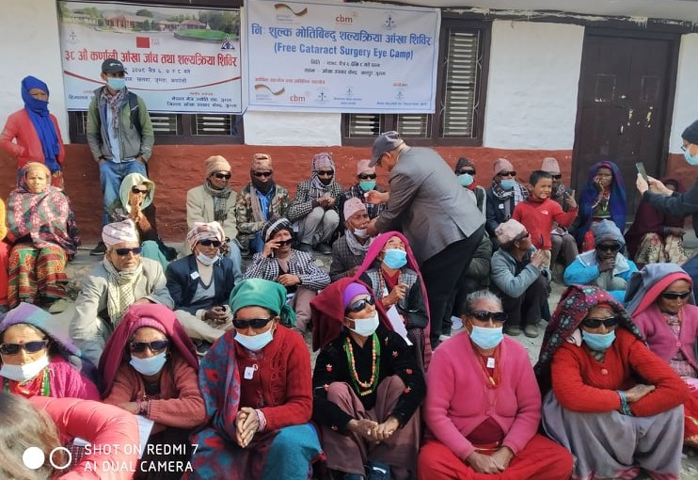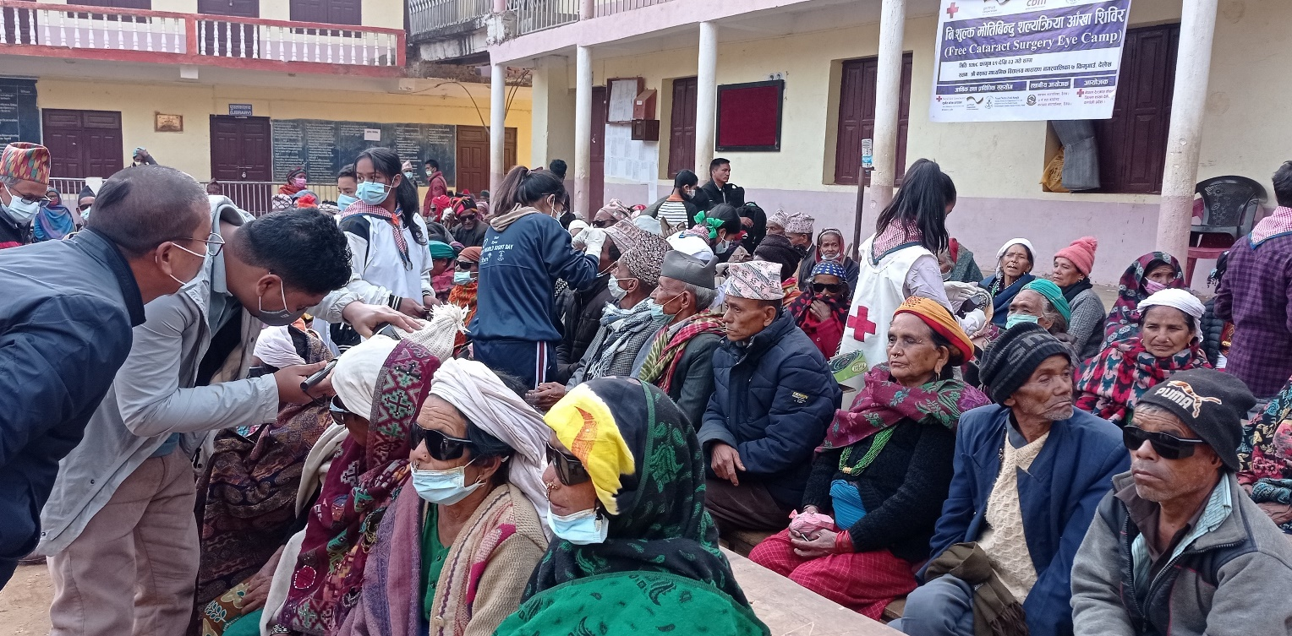Photos

**Cataract Surgical Camp at Chandannath, Jumla**

**Cataract surgical Camp at Kimugaun, Dailekh**

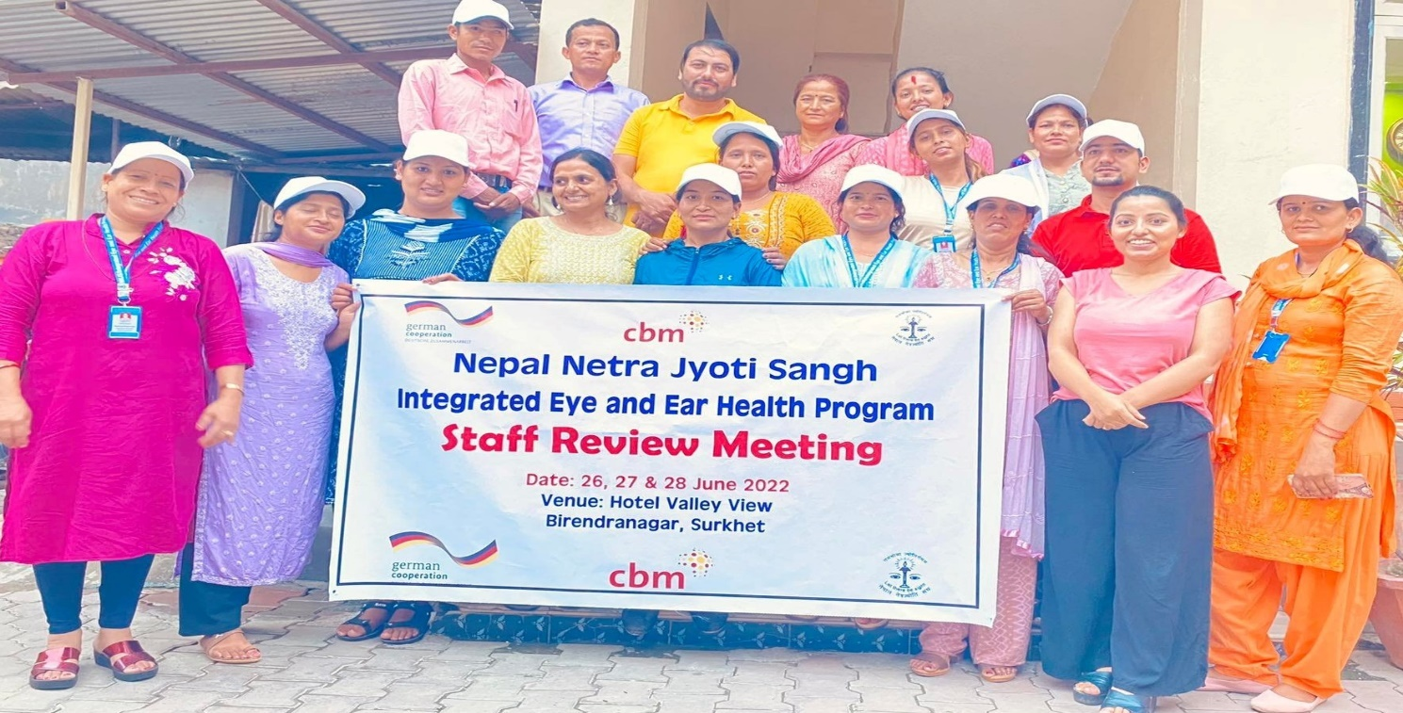

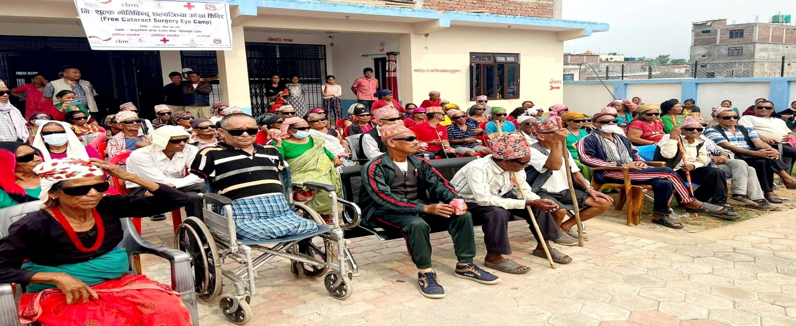**Project Staff Quarterely Review Meeting at Surkhet**

**56 Cataract Surgeries performed at Upgraded Surgical Eye Centre, Gurvakot, Surkhet in May 2022**

1. Comments from responsible CBM Office

CBM Nepal country office has considered this project one of the important projects of country office and has been monitoring and support closely with NNJS and Surkhet eye hospital. Project has made much progress as compared to 2021. We can observe, service delivery from newly established primary eye care center and they are owned and run by local government as envisioned by project and ensure the sustainability of those PEECS. Similarly, newly upgraded surgical center is fully functional and has been providing cataract surgery on periodic basis. Karnali is one of the biggest provinces of Nepal with scattered population in mountainous and hilly reason. Projet has succussed to deliver eye services along with surgical camp in very remote areas and contributing to reduce disability and poverty in the region with numeros learnings. All the community programs are on track and progressive. Surkhet eye hospital service delivery has strengthened and have reached to more people. Subsidy under project is utilized for those clients who are real poor and in condition to exclude from services without subsidy scheme. As a result, client under national health scheme and self-paying are increasing which also ensure the sustainability of Surkhet eye hospital.

We have collectively realized and becoing proactive on awareness raising part and referrals. NNJS is aware on it and community awareness activities are designed in this regard.

**NNJS** is expected to start ear survey in next six-month, which process has started from expression of interest call to recruit survey firm/organization. NNJS is also expected to work on integration of national and provincial eye health strategies under national health policy. Draft has been already ready on both levels. CBM will facilitate to organize policy dialog, lobby and coordination at both levels. CBM focus for next six month will be to facilitate/support to increase base hospital surgery, support on eye survey and ensure implementation of remaining community activities and ensure BMZ compliance are met in project implementation. With the learnings and commitments from NNJS we the *sustainability* and service seeking practice from the community is gradually increasing. CBM will be very closely observing and facilitating in the entire process of project implemenation, quality maintainance and sustainability practices.